SMART HIGHWAY LIGHT CONTROL SYSTEM BY PIR MOTION SENSOR

MD. BAKHTIAR AZIM NIOY  
Computer Science and engineeringAmerican International University-BangladeshDhaka, Bangladesh  
19-41011-2@student.aiub.edu

MD. TAREQUL ISLAM  
Computer Science and engineeringAmerican International University-BangladeshDhaka, Bangladesh  
18-37816-2@student.aiub.edu

JIHAD SHAHARIAR JOY   
Computer Science and engineeringAmerican International University-BangladeshDhaka, Bangladesh  
19-40068-1@student.aiub.edu

ROMIJ UDDIN AHMED CHOWDHURY  
Computer Science and engineeringAmerican International University-BangladeshDhaka, Bangladesh  
18-37800-2@student.aiub.edu

MD FASIUL AHSAN  
Computer Science and engineeringAmerican International University-BangladeshDhaka, Bangladesh  
19-40959-2@student.aiub.edu

*Abstract*—

The project is conducted to upgrade the highway light system and save a great amount of energy that is used to power the highway lights. Here we have tried to build a system that will automatically keep the highway lights OFF if not necessary and will turn the lights ON if necessary. Here we have used PIR Motion Sensors to detect any humans or vehicles on the road. The project code is designed as if a motion sensor detects the movement of humans or vehicles on its side of the road, then it will turn the light on for only that side of the road and it is the same for the other sensor. Nowadays, in Bangladesh the energy supply is low and the people face a lot of load-shedding. This is where our project takes place because this project saves a great amount of energy and this project is very budget-friendly and can be implemented in a very short amount of time. For a country like Bangladesh where energy is limited, this energy-saving method of highway light system will be a technological evolution.

Keywords— Arduino, PIR, Density, Signal.

# **Introduction**

Street lights are an essential element of the roads. Whenever we travel or walk outside at night, the lights show us the way clearly. As civilization has advanced, we have street lights almost everywhere and even on the highways which we use to travel long distances. But, even if the highway does not stay crowded the lights stay on for the whole night. Which is a great waste of energy.

Currently, only embedded brightness sensors are used to regulate street lights; they automatically turn on when it gets dark and turn off when it is bright. This is a major waste of energy and that has to be changed. In our project, we want to implement an energy-saving system where the lights will turn off when not needed and turn on only when necessary.

# **Literature Review:**

Noriaki Yoshiura, Yusaku Fujii, Naoya Ohta (2013) [1] mentioned a concept of an autonomous-distributed controlled light system which is proposed by Fujii et al (Japan), in a conference paper, where all the street lights are connected to a network that sends a signal to nearby lights if motion is detected.

This kind of smart street light exchanges information of detecting moving objects and turn them on so that neighborhood of the moving objects lightens. The method is tracking the detection of the existence of pedestrians or vehicles using several kinds of sensors. Also, Image processing is used that obtain pictures and adjust the brightness of the lights. The idea of this system can be helpful for building our proposed system.

The major drawbacks of this system are safety, privacy, and damage issues. Image processing is a hindrance to privacy and if one light is damaged, that can be known if anyone reports it and can be fixed only by physically going to that place. If someone is hiding somewhere or a vehicle is stopped, the light will also turn off which is a major safety issue.

The centrally-controlled system with host computers is also a result of research that was mentioned by Noriaki Yoshiura (2017) [2]. A Zigbee communication module was used to communicate with the servers, sensors, and other street lights. Which sends a signal to the server/host computer if a pedestrian or vehicle is detected and the server decides that the lights should turn on. Every smart light has one module to communicate.

But the time lag to communicate with the servers and the high cost of the host computer is the major flaw of this system.

Being an energy-saving era, it is necessary to save energy effectively. The “Street Light System based on Piezoelectric Sensor Networks” by R. Abinaya, V. Varsha, and Kaluvan Hariharan's (2016) [3] journal paper explains how the energy can be saved from the street lights through effective management using sensors. This project requires piezoelectric sensors to detect the vehicle's movements and accordingly switch on the lights ahead of it. In our project, we can use piezoelectric sensor system information and we can gather knowledge on how to use this sensor.

In this review, some articles/journals were summarized and evaluated in terms of cost, time, repair, privacy, safety, etc. By improving every section, a sensor-controlled street/highway light system can be implemented in which both the pedestrians and vehicle drivers will be benefitted.

# **Methodology and Modeling**

Highway controlling administration has the goal of constantly improving the lighting systems and regulations As the number of vehicle users constantly increases and resources provided by current infrastructures are limited, intelligent control of highway lighting will become a point of focus in the future. Avoiding waste of electricity is beneficial to both environment and the economy. In our research, we focus on and optimize light controllers in highway using PIR sensors and developing them using Arduino. An intelligent transportation system (ITS) estimates the highway parameters and optimizes highway light system to reduce waste of electricity and fixing the problem of accident controlled according to the density, but in a manner of programming which is already fixed in the system. This paper proposes an intelligent system using Arduino for implementation in the highway.

## **Working principle of the proposed project:**

A passive infrared sensor-based prototype a self–adaptive highway light control system has been developed in this paper. An autonomous highway light system can effectively measure the congestion of the urban highway system. This system adjusts the signal parameters according to the intensity of vehicles' respective motions and improves the efficiency of operations in road networks. The self–adaptive highway light signal system is a closed loop control system. It measures the motion of vehicles on the highway and gives a priori lighting.

## **Process of Work:**

The architecture of the highway road intersection with the PIR sensor module is shown in Fig. Here represent the roads. Road has some PIR sensors. One is at the front of the road another middle of the road. When vehicles reaches in front of the second PIR sensor, the output signal from the sensor is considered as the road density. Those lane's last sensor detects vehicles, the more the density of vehicles on that road to give more signal for lighting more in the highway, the following rules are executed:

1) If no PIR sensor is detecting a signal, then each road will not be given no signal of lighting in the highway.

2) If one vehicle in the highway PIR sensor detects the vehicle. Then this road gives lighting on the road.

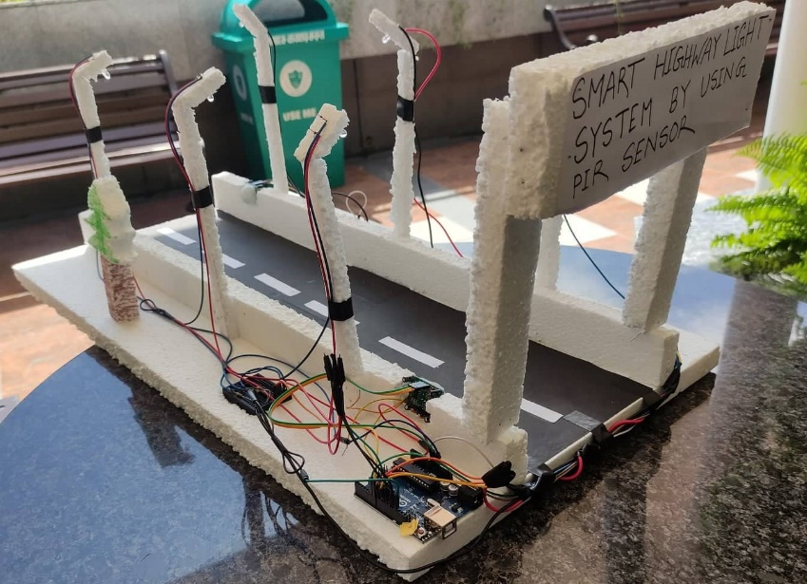

Fig-1- SMART HIGHWAY LIGHT CONTROL SYSTEM

## **Description of the important component:**

Arduino board:

Arduino is an open-source electronics platform based on easy-to-use hardware and software. Arduino boards can read inputs - light on a sensor, a finger on a button, or a Twitter message - and turn them into an output - activating a motor, turning on an LED, publishing something online.

Bread Board:

A breadboard is used for building temporary circuits. It is useful to designers because it allows components to be removed and replaced easily. It is useful to the person who wants to build a circuit to demonstrate its action, then reuse the components in another circuit.

PIR Sensor:

A PIR (Passive Infrared) sensor is an electronic device that can be used to sense certain parameters of its surroundings by either emitting or detecting radiations. It can also measure the heat of an object and detect motion. It uses infrared light to sense objects in front of them and map or guess their distance. This system consists of 2 PIR sensors. The PIR transmitter looks like an LED. This PIR transmitter always emits IR rays from it. The operating voltage of this IR transmitter is 2to 3v. Generally, the PIR receiver has high resistance in the order of mega ohms but when it is receiving IR rays the resistance is very low. The operating voltage of the IR receiver is also 2 to 3V. We have to place

Jumper wires:

Jumper wires are used for making connections between items on the breadboard and Arduino’s header pins. We use them to wire up all our circuits.

Led:

We used 6 Led lights. Those led give the signal to according to the vehicles.

Power supply:

It simply provides power to keep the microcontroller active. The power supply source is the electricity.

## **Implementation:**

At first, we drew a circuit diagram for our project than we first implemented the lights in the side of the 2 lines highway roads. And then we placed 2 sensors in every lane in 10 inches gaps and then we implemented to give electric power to the whole system and we used Arduino Uno in our project and a breadboard for wire connection. We used favicon gum and drill some places in our board and placed tight with nuts and bolts. Then we connected female-female wires with 6 led lights and 2 PIR sensors. Then we connected those wires with male to male wires and placed male wires on the breadboard and then we implemented those wires in Arduino.

**ARDUINO CODE:**

int LED1 = 13;

int LED2 = 12;

int LED3 = 11;

int LED4 = 10;

int LED5 = 9;

int LED6 = 8;

int PIR1 = 7;

int PIR2 = 6;

void setup() {

// initialize digital pin 3 as an output for LED

pinMode(LED1, OUTPUT);

pinMode(LED2, OUTPUT);

pinMode(LED3, OUTPUT);

pinMode(LED4, OUTPUT);

pinMode(LED5, OUTPUT);

pinMode(LED6, OUTPUT);

//initialize digital pin 10 as input for PIR

pinMode(PIR1, INPUT);

pinMode(PIR2, INPUT);

Serial.begin(9600);

//initialization time for PIR sensor to warm up

//blink LED to show that something is happening

}

void loop() {

//read PIR sensor, if High light LED for 5 seconds

//if low, check again

if(digitalRead(PIR1) == HIGH) {

Serial.println("Motion1 detected");

digitalWrite(LED1, HIGH);

digitalWrite(LED2, HIGH);

digitalWrite(LED3, HIGH);

delay(5000);

}

else if(digitalRead(PIR2) == HIGH){

Serial.println("Motion2 detected");

digitalWrite(LED4, HIGH);

digitalWrite(LED5, HIGH);

digitalWrite(LED6, HIGH);

delay(5000);

}

else {

Serial.println("No Motion detected");

digitalWrite(LED1, LOW);

digitalWrite(LED2, LOW);

digitalWrite(LED3, LOW);

digitalWrite(LED4, LOW);

digitalWrite(LED5, LOW);

digitalWrite(LED6, LOW);

delay(1);

}

}

## **Test/Experimental setup:**

After completing our implementation then we made essential code in Arduino and upload it to Arduino Uno then we turn on the project and first checked whether our project component is running or not. Then we saw that our all led lights are working properly then we checks the PIR sensors. We first put an object in front of every object. Every sensor has 3 lights were always on. It means it is working properly and when it can detect any object in front of another 3 led lights would be on and it means that the sensor is working properly and detecting the objects. Because our sensors can detect every object in front of us. So when vehicles come to a lane then immediately the PIR sensor detects the vehicles and then the led lights are on the road.

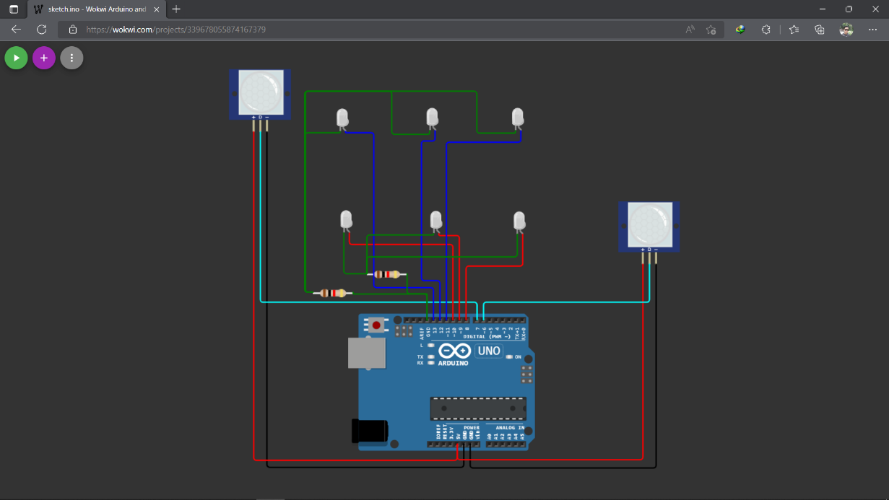

Fig- 2- Diagram of Smart Highway Light Control System

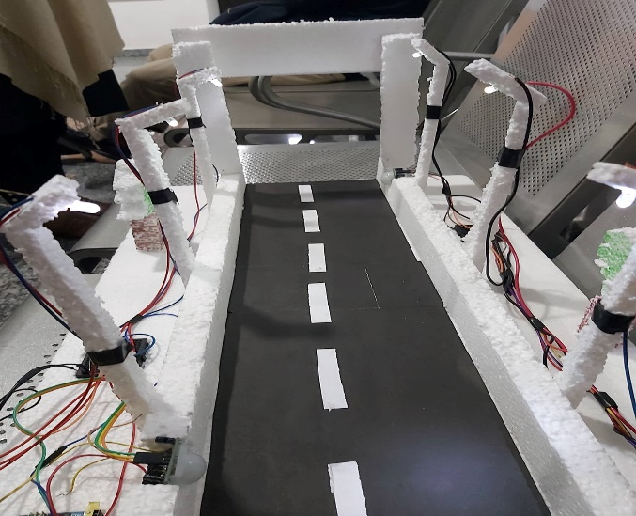

Fig- 3- SMART HIGHWAY LIGHT CONTROL SYSTEM

## **Cost analysis:**

●Arduino UNO —> 1350/=

● PIR Sensor —>300/=

● LED Lights —> 50/=

● Bread Board —> 160/=

● Connection Wire0 —> 80/=

● Board —> 400/=

Total Cost (around) = 3000/= BDT

# **Results and Discussion:**

The smart highway light control system which is controlled by an Arduino UNO microcontroller and PIR motion sensor is set up. The sensors are placed after some distance between one another on the road. For each sensor, several lights are assigned and if the sensor detects the movement of humans or vehicles, then it will turn those lights ON that are assigned to it. In this case, it will control the lights for only one side of the road. Arduino UNO will provide a flexible time delay of the lights ON state for vehicles to pass that part of the road with ease. If there is no vehicle on road it will turn every light OFF that is assigned to it and save energy.

# **Conclusion:**

In conclusion, the development of this Smart Highway Light control system using PIR motion sensors is done very well. By applying this system, it can reduce energy wastage on ever-lasting highway lights. It also can reduce road accidents in the present and future. The usage of the Arduino UNO microcontroller contributes to a very appropriate model to implement the embedded control system because it is easy to be modified to any possibility in meeting future requirements hassle-free and quickly.

In the upcoming times, an enhancement to improve the features of this project can be done such as using the ultrasonic sonar sensor or the IR sensor system and artificial camera to increase the functionality and efficiency of the system.

##### **References**

[1] Noriaki Yoshiura, Yusaku Fujii, Naoya Ohta ; ‘Smart street light system looking like usual street lights based on sensor networks’; Conference paper (2013); DOI: 10.1109/ISCIT.2013.6645937

<https://www.researchgate.net/profile/Naoya-Ohta/publication/261479865_Smart_street_light_system_looking_like_usual_street_lights_based_on_sensor_networks/links/54e5ac9b0cf22703d5c19a65/Smart-street-light-system-looking-like-usual-street-lights-based-on-sensor-networks.pdf>

[Accessed June 28, 2022]

[2] Noriaki Yoshiura ; ‘Smart street light system based on IoT’ from ‘Proceedings of International Conference on Technology and Social Science 2017’; Conference paper (2017)

<http://www.e-jikei.org/Conf/ICTSS2017/proceedings/materials/proc_files/Keynote%20paper_ICTSS2017_%5Bprof.Yoshiura%5D/ICTSS2017-yoshiura-.pdf>

[Accessed June 29, 2022]

[3] R. Abinaya, V. Varsha, and Kaluvan Hariharan; 'An Intelligent Street Light System based on Piezoelectric Sensor Networks'; Article 64(2016); Indian Journal of Science and Technology, Vol 9(43), DOI: 10.17485/ijst/2016/v9i43/102879, November 2016

<https://sciresol.s3.us-east-2.amazonaws.com/IJST/Articles/2016/Issue-43/Article64.pdf>

[Accessed June 29, 2022]